**Introduction to PEGA Ethos**

Ethos is derived from a Greek term used to describe distinguishing

practices, values and ideals.

Enterprise solutions are built using Pega and its ethos.

• Low-code

• Model-driven(a format to write and implement software quickly, effectively and at minimum cost)

• Visual design

• Rule-based

• Reusable components

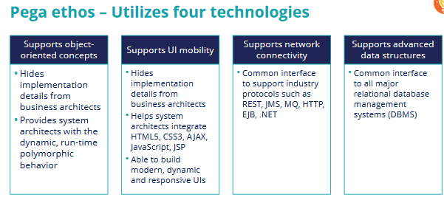

Pega Rules Process Commander (PRPC)

Pega Platform access

Operator ID rule – User ID and password to access Pega application resources

Access Group rule – Defines the applications available to the user with the level of access

(role and privilege)

Application rule – Defines application resources (rulesets, classes and rule instances)

• Rule – Logical instructions

• Class – Grouping of rule instances

• RuleSet – Container of classes and rule instances for deployment

